**CIS 602 – Big Data Analytics - Fall 2024**

Report

**Submitted by: Group – 2**

Rama Satya Sai Prasad Appari (01) Bhadiyadra Om Sureshbhai (06) Patel Malav Vasantbhai (36)

**Real-Time Traffic Data Analytics Using Azure Introduction**

Traffic congestion is a growing challenge in urban areas, impacting travel times, fuel consumption, and environmental conditions. This project aims to address these challenges by creating a real-time traffic monitoring and analytics solution using Azure cloud services.

The solution integrates live traffic data from the HERE Traffic API with weather data from weather.com, providing detailed insights into traffic patterns and enabling better decision-making for route optimization and traffic management. The project employs a fully automated data pipeline, leveraging the robustness of Azure Functions, Event Hub, Fiber Event Stream, and KQL (Kusto Query Language) databases for seamless data processing and storage.

By utilizing Power BI, the project visualizes data in an intuitive and interactive manner. This ensures that users can easily identify traffic congestion areas, analyze how weather impacts traffic, and make informed decisions to improve transportation efficiency. Ultimately, the project showcases how real-time data analytics can help modernize traffic management systems.

**Project Overview**

The primary objective of this project is to design and implement a real-time traffic analytics system that provides accurate and actionable traffic insights. The project addresses the need for reliable traffic monitoring solutions in urban areas, where congestion and unpredictable weather conditions often lead to inefficiencies.

**Key Components of the Project**

1. **Traffic Data Collection:** Real-time traffic data is gathered using the HERE Traffic API, which provides detailed information on congestion levels, vehicle speeds, and jam factors.
2. **Weather Data Integration:** Weather data, such as temperature, visibility, wind speed, and cloud cover, is retrieved from weather.com through web scraping. This data is critical for analyzing how weather conditions affect traffic patterns.
3. **Data Processing Pipeline:** Azure’s cloud services form the backbone of the data pipeline:
   * **Azure Functions:** Automates the process of fetching data every 10 minutes.
   * **Azure Blob Storage:** Temporarily stores raw data files before processing.
   * **Azure Event Hub:** Streams data in real-time to ensure a continuous flow.
   * **Fiber Event Stream:** Processes and transforms the raw data, making it ready for analysis.
   * **KQL Database:** Organizes and stores processed data for efficient querying and retrieval.
4. **Visualization with Power BI:** The processed data is visualized using Power BI, providing a comprehensive view of traffic and weather trends. Key features include:
   * Real-time updates to track traffic congestion and weather conditions.
   * Visual correlation between weather parameters and traffic patterns.
   * Interactive dashboards for user-friendly data exploration.

**Why Azure?**

Azure’s ecosystem is chosen for its reliability, scalability, and real-time processing capabilities. Its services, such as Functions, Blob Storage, and Event Hub, seamlessly integrate to handle large volumes of data with minimal latency. Additionally, Azure’s support for KQL ensures efficient querying, while Power BI’s integration allows for visually rich, actionable insights.

**Project Goals**

The project aims to:

1. Enhance traffic monitoring through real-time data collection and analysis.
2. Offer predictive insights by correlating weather data with traffic conditions.
3. Reduce congestion by providing actionable recommendations for route optimization.
4. Demonstrate the feasibility of using Azure cloud services for smart city solutions.

**Value Proposition**

This project highlights how real-time analytics can revolutionize urban traffic management. By combining live traffic and weather data, it offers municipalities, transportation agencies, and commuters the tools they need to make data-driven decisions that save time, reduce costs, and improve overall travel experiences.

**Objectives**

The project is driven by four core objectives, each targeting a specific aspect of traffic monitoring and management:

**1. Real-Time Traffic Monitoring**

The primary objective is to continuously collect and update traffic data to provide up-to-the-minute insights into traffic conditions. This includes:

* **Congestion Analysis:** Identifying high-traffic zones and their patterns throughout the day.
* **Speed Variations:** Monitoring average speeds to highlight areas with slow-moving traffic or potential bottlenecks.
* **Jam Detection:** Using the "jam factor" metric from the HERE Traffic API to detect and predict traffic jams.

Real-time monitoring enables transportation agencies and commuters to make informed decisions, reducing delays and optimizing travel times.

**2. Weather-Integrated Traffic Analysis**

Weather significantly impacts traffic flow, with conditions like rain, fog, or snow often causing delays and accidents. By incorporating live weather data, the project aims to:

* Examine correlations between weather parameters (e.g., visibility, temperature, wind speed) and traffic patterns.
* Predict traffic disruptions caused by adverse weather conditions.
* Provide insights to optimize traffic management during extreme weather events.

**3. Seamless Data Processing Pipeline**

The project ensures smooth data flow from collection to visualization by implementing a robust data pipeline. The goals include:

* Automating data collection using Azure Functions to eliminate manual intervention.
* Ensuring real-time data streaming and processing through Azure Event Hub and Fiber Event Stream.
* Storing data efficiently in a KQL database to facilitate quick queries and retrievals.

**4. Live Data Visualization**

The final objective is to provide an interactive platform for visualizing traffic and weather insights. With Power BI, users can:

* View traffic patterns and weather data in real-time.
* Identify trends and correlations through visually intuitive graphs and maps.
* Gain actionable insights to improve route planning and traffic management.

**Methodology - Data Collection**

The project employs a structured methodology to ensure the accuracy and relevance of the data collected. The two key data sources are traffic and weather data, both of which are crucial for understanding traffic dynamics.

**Traffic Data Collection**

* **Source:** HERE Traffic API.
* **Metrics Collected:**
  + **Congestion Levels:** Identifies areas with high traffic density.
  + **Speed Metrics:** Tracks average vehicle speeds on different routes.
  + **Jam Factor:** A numerical representation of traffic severity, ranging from smooth traffic to severe congestion.
* **Collection Frequency:** Data is fetched every 10 minutes to maintain real-time accuracy.
* **Challenges Addressed:**
  + Ensures low latency in data collection.
  + Handles high-volume data streams without performance issues.

**Weather Data Collection**

* **Source:** Weather.com.
* **Methodology:** Web scraping using Python's BeautifulSoup library.
* **Metrics Collected:**
  + **Temperature:** Captures real-time temperature to study its effect on traffic.
  + **Visibility:** Tracks atmospheric clarity, critical during foggy or smoky conditions.
  + **Wind Speed:** Measures wind conditions, particularly important during storms.
  + **Cloud Cover:** Examines general weather patterns impacting visibility and travel.
* **Integration with Traffic Data:** Weather data is combined with traffic data to explore how external conditions influence driving behavior, congestion, and accident rates.

**Tools for Data Collection**

1. **HERE Traffic API:** Provides robust, reliable, and comprehensive traffic data.
2. **BeautifulSoup:** A Python library used for extracting weather data from HTML web pages.

**Why Focus on These Data Sources?**

By integrating both traffic and weather data, the system can provide:

* A holistic view of the factors influencing traffic conditions.
* Predictive insights to prepare for disruptions caused by adverse weather.
* Data-driven recommendations for improving traffic flow and safety.

**Data Validation**

To ensure the accuracy and reliability of the collected data:

* Traffic data is cross-verified with other API metrics (e.g., historical data trends).
* Weather data is checked for consistency with alternate weather sources during web scraping.

This dual-layered data collection strategy sets the foundation for the subsequent stages of data processing and visualization.

**Methodology - Data Processing and Storage**

Data processing and storage are crucial components of the project, ensuring the collected data is transformed, organized, and readily accessible for real-time analytics. Azure's ecosystem is utilized for building a seamless, automated data pipeline.

**1. Azure Functions**

Azure Functions act as the backbone of data automation in this project. They perform the following tasks:

* **Automation:** Scheduled to run every 10 minutes, the function fetches data from the HERE Traffic API and weather.com.
* **Raw Data Storage:** Stores the collected raw data in Azure Blob Storage as CSV files.
* **Data Streaming:** Sends the raw data to Azure Event Hub for real-time processing.

By automating these steps, Azure Functions eliminate manual intervention, ensuring consistent and error-free data collection.

**2. Azure Event Hub**

Azure Event Hub serves as a highly scalable data streaming platform. Its role includes:

* **Real-Time Streaming:** Processes incoming data streams from Azure Functions.
* **Data Transfer:** Forwards data to Fiber Event Stream for further processing.
* **High Throughput:** Handles large volumes of data efficiently, making it ideal for real-time analytics projects like this one.

**3. Fiber Event Stream**

The Fiber Event Stream is responsible for transforming raw data into a usable format. Key activities include:

* **Data Cleaning:** Removes inconsistencies and handles missing values in the data.
* **Data Transformation:** Converts raw metrics into formats suitable for storage and analysis, such as aggregating traffic statistics by region or time interval.
* **Transfer to KQL Database:** Streams the processed data to the KQL database for organized storage.

**4. KQL Database**

The processed data is stored in a KQL (Kusto Query Language) database. This system offers:

* **Efficient Querying:** Optimized for both historical and near-real-time data analysis.
* **Data Organization:** Structures data into tables based on traffic and weather metrics, making it easy to retrieve and analyze specific data points.
* **Scalability:** Supports high data volumes and rapid querying, crucial for real-time applications.

**Data Security**

Data security is prioritized throughout the pipeline:

* **Encryption:** All data transfers are encrypted to protect sensitive information.
* **Access Control:** Azure's role-based access controls ensure only authorized personnel can access or modify data.

**Why This Approach?**

This methodology ensures:

1. **Automation:** The system runs without manual intervention, reducing human errors.
2. **Scalability:** The architecture can handle increasing data volumes as the system grows.
3. **Speed:** Near-real-time data processing ensures insights are always up to date.

**Methodology - Visualization**

Visualization transforms raw data into actionable insights, making it accessible and understandable for end-users. Power BI is used to create an interactive, user-friendly dashboard that updates in real time.

**1. Power BI Dashboard**

The Power BI dashboard is the project's central visualization tool. It provides:

* **Real-Time Updates:** Automatically refreshes every few minutes to display the latest traffic and weather data.
* **Interactive Insights:** Users can interact with graphs, charts, and maps to explore traffic patterns and weather impacts.
* **Customizable Views:** Enables users to filter data by location, time, or weather conditions for targeted analysis.

**2. Key Metrics Visualized**

The dashboard showcases the following key metrics:

* **Traffic Data:**
  + Congestion heatmaps highlighting high-traffic zones.
  + Speed trends across major routes to identify slow-moving areas.
  + Jam factor graphs showing the severity of traffic jams over time.
* **Weather Data:**
  + Temperature and visibility trends impacting driving conditions.
  + Wind speed and cloud cover data displayed alongside traffic metrics to explore correlations.
* **Combined Analysis:**
  + Overlay of weather and traffic data to show how weather conditions influence congestion and travel times.
  + Predictive charts suggesting potential disruptions based on current weather patterns.

**3. Benefits of Visualization**

1. **Simplified Data Interpretation:** Converts complex datasets into visual formats for easier understanding.
2. **Actionable Insights:** Highlights key trends and anomalies, enabling quick decision-making.
3. **Improved Traffic Management:** Helps traffic authorities predict and address congestion effectively.
4. **Enhanced User Experience:** Allows commuters to plan routes with real-time, data-driven insights.

**4. Visualization Example**

A typical Power BI dashboard might include:

* A live map displaying traffic congestion levels with color-coded routes.
* Line graphs showing how visibility changes impact average speeds over time.
* Bar charts comparing weather conditions during peak and non-peak traffic hours.

**Challenges in Visualization**

1. **Data Synchronization:** Ensuring traffic and weather data align in real time.
2. **Scalability:** Designing a dashboard that performs efficiently with growing data volumes.
3. **Customization Needs:** Addressing varying requirements for different user groups, such as traffic managers vs. commuters.

By combining the power of real-time data processing and advanced visualization, the project equips users with the tools needed to make informed decisions and optimize traffic management strategies effectively.

**Tools and Technologies**

The success of this project relies on a carefully selected set of tools and technologies that enable seamless data collection, processing, storage, and visualization. Each tool is chosen for its compatibility with Azure's ecosystem and its ability to handle real-time data streams.

**1. Data Collection Tools**

* **HERE Traffic API:**
  + Provides comprehensive traffic data, including congestion levels, average speed, and jam factors.
  + Offers high reliability and scalability for real-time applications.
  + API endpoints are configured to fetch data every 10 minutes.
* **BeautifulSoup (Python Library):**
  + Used for web scraping weather data from weather.com.
  + Extracts key metrics such as temperature, visibility, wind speed, and cloud cover.
  + Lightweight and efficient, suitable for frequent scraping tasks.

**2. Data Processing and Storage Tools**

* **Azure Functions:**
  + A serverless computing service that automates data collection.
  + Runs scheduled scripts to fetch and forward data with minimal latency.
  + Eliminates the need for dedicated servers, reducing operational overhead.
* **Azure Blob Storage:**
  + Temporarily stores raw data files in a scalable and secure environment.
  + Acts as the first layer of data storage before streaming to Event Hub.
* **Azure Event Hub:**
  + A real-time data streaming platform capable of handling high data throughput.
  + Ensures continuous data flow from collection to processing systems.
  + Integrates seamlessly with other Azure services for downstream processing.
* **Fiber Event Stream:**
  + Processes data received from Event Hub, performing cleaning and transformations.
  + Prepares data for storage in the KQL database, ensuring it's analysis-ready.
* **KQL Database (Kusto Query Language):**
  + Optimized for handling large datasets with minimal latency.
  + Enables both historical and real-time data analysis.
  + Supports complex queries for traffic and weather correlations.

**3. Visualization Tools**

* **Power BI:**
  + Provides interactive dashboards for visualizing traffic and weather data.
  + Allows users to create custom views and filters for targeted analysis.
  + Updates in near real time, ensuring data remains current and actionable.

**4. Why These Tools?**

The chosen tools were selected for their:

* **Scalability:** Able to handle increasing data volumes as the project grows.
* **Efficiency:** Support real-time data processing and visualization.
* **Integration:** Work seamlessly within Azure’s cloud ecosystem.

**Advantages of Azure Ecosystem**

1. **Reliability:** Azure services are designed for high availability and minimal downtime.
2. **Flexibility:** Supports a wide range of data sources, formats, and processing needs.
3. **Cost-Effectiveness:** Serverless architecture reduces costs by charging only for active usage.

**Screenshots and System Architecture**

**1. System Architecture Overview**

The system architecture outlines the flow of data from collection to visualization. Each component plays a specific role in ensuring real-time insights are delivered efficiently.

* **Data Collection:**
  + Traffic data is fetched from the HERE Traffic API.
  + Weather data is scraped from weather.com using BeautifulSoup.
  + Azure Functions automate these tasks and store raw data in Azure Blob Storage.

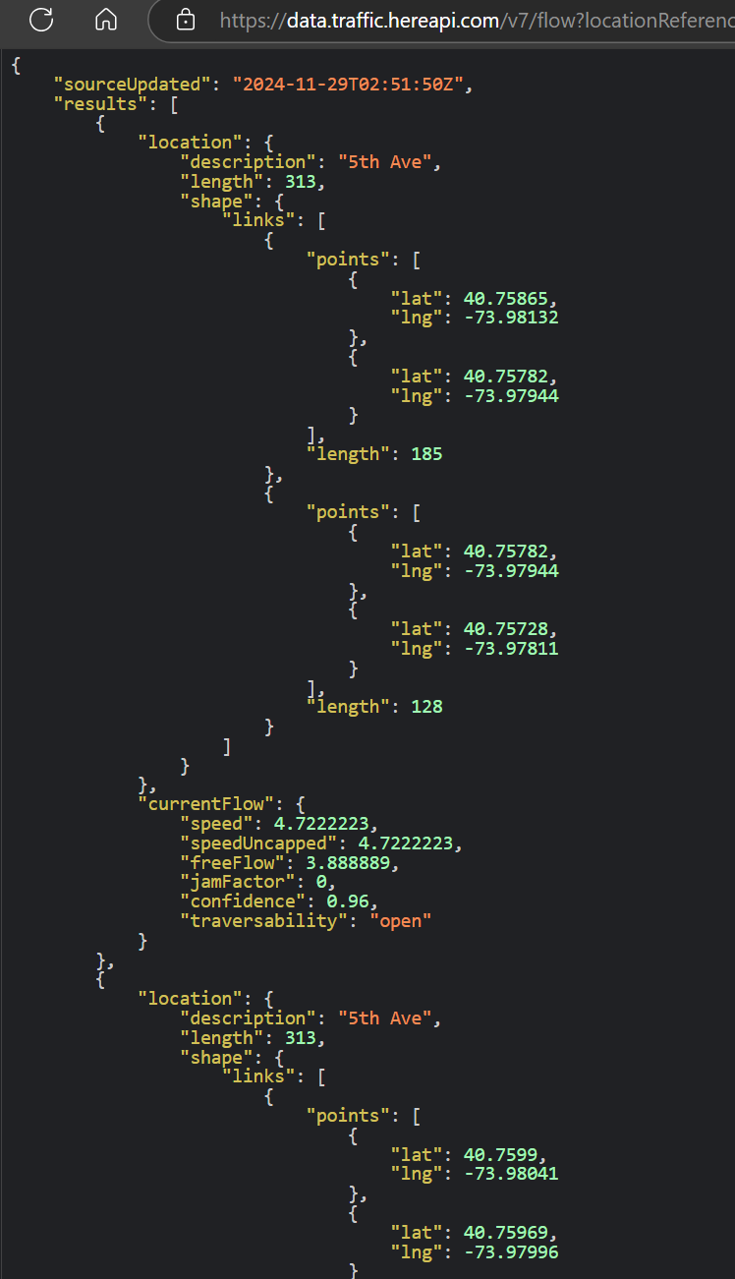

* **Data Processing:**
  + Raw data is streamed from Azure Blob Storage to Azure Event Hub.
  + The Fiber Event Stream processes and cleans the data, preparing it for storage.
  + Cleaned data is stored in a KQL database for querying.

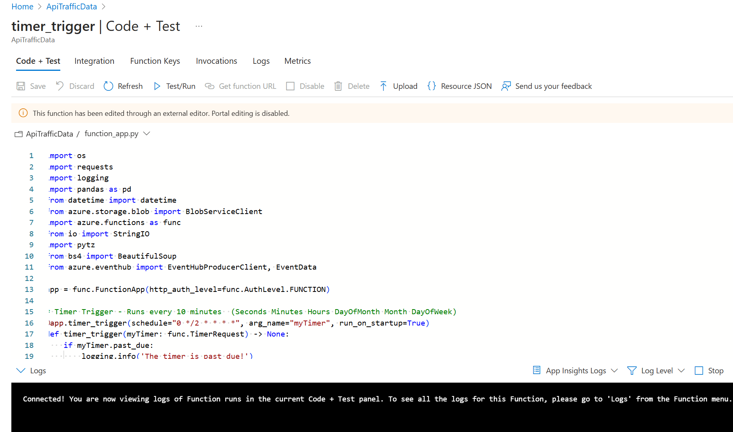

* **Visualization:**
  + Power BI connects to the KQL database to generate real-time dashboards.
  + Users can explore insights such as congestion trends, speed metrics, and weather impacts.

**2. Example Screenshots**

1. **Power BI Dashboard:**
   * A real-time heatmap showing traffic congestion across a city.
   * Line charts comparing traffic speed trends during clear and adverse weather conditions.
   * Bar graphs correlating weather metrics (e.g., visibility) with traffic jams.

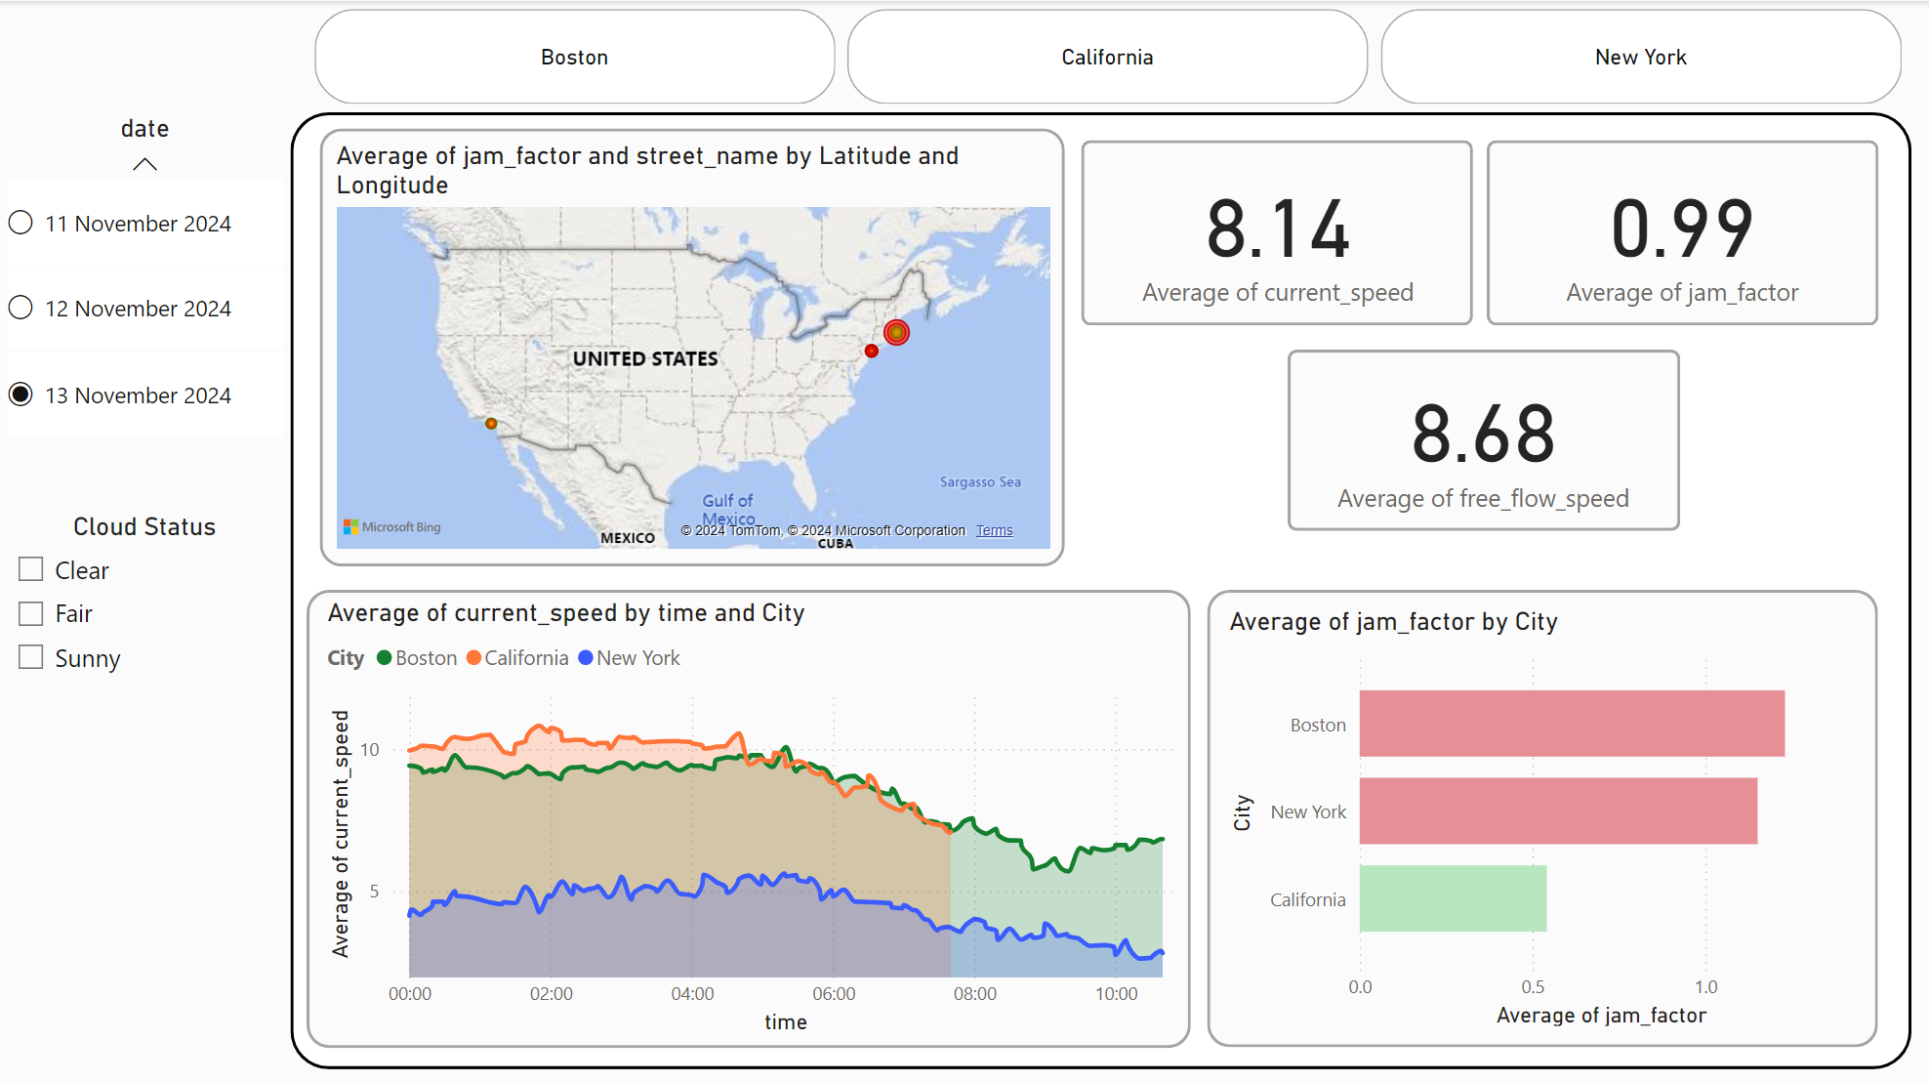

1. **KQL Database Queries:**
   * Sample query outputs displaying average speeds, congestion levels, and weather conditions for specific routes and times.
   * Historical data retrieval to analyze trends over weeks or months.

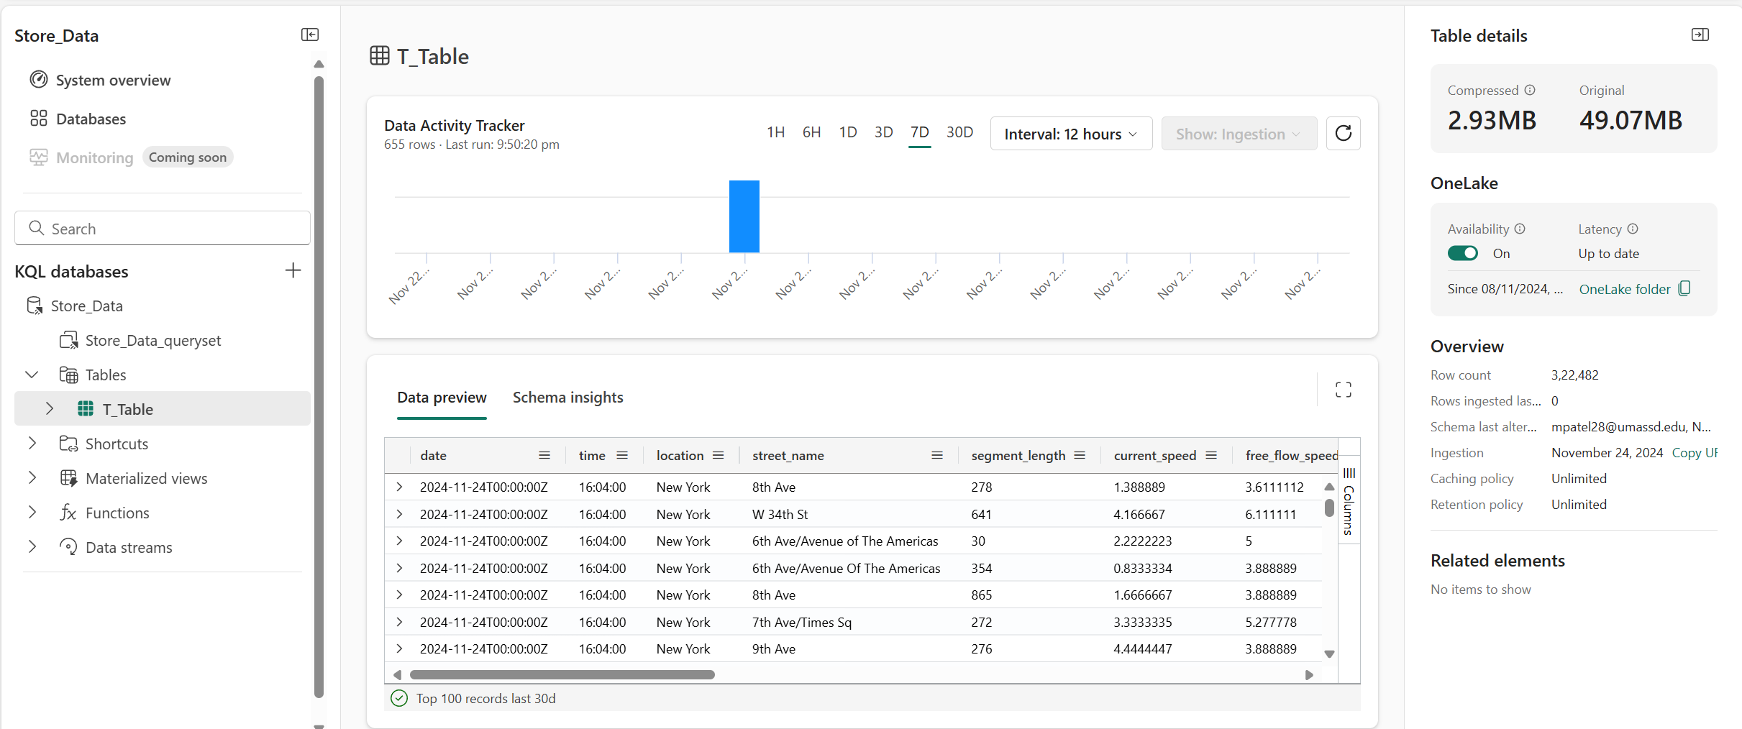

1. **System Workflow:**
   * Flow diagrams illustrating the data pipeline from API and web scraping to Power BI dashboards.

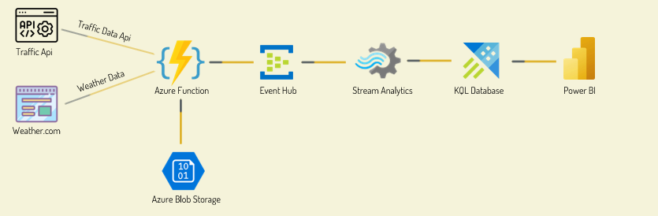

**3. Key Features of the Architecture**

* **Modularity:** Each component (data collection, processing, storage, visualization) operates independently, allowing for easier troubleshooting and upgrades.
* **Real-Time Insights:** The architecture ensures minimal delays between data collection and visualization.
* **Scalability:** The system can be expanded to handle additional data sources or larger geographic areas without significant reconfiguration.

**Challenges and Solutions**

1. **Challenge:** Synchronizing traffic and weather data in real time.
   * **Solution:** Align collection schedules to ensure both data types are captured at the same intervals.
2. **Challenge:** Handling high data volumes during peak traffic times.
   * **Solution:** Optimize processing pipelines with Azure Event Hub and Fiber Event Stream to maintain low latency.
3. **Challenge:** Ensuring accuracy of web-scraped weather data.
   * **Solution:** Implement validation checks and cross-reference data with alternate weather sources.

This section highlights how the combination of tools, technologies, and system design enables the project to deliver on its objectives, offering a robust solution for real-time traffic and weather analytics.

**Expected Outcomes**

The project's implementation promises several key outcomes, each contributing to better traffic management and decision-making capabilities.

**1. Real-Time Traffic Insights**

* **Live Monitoring:** Users gain access to real-time data on congestion levels, traffic speeds, and potential bottlenecks.
* **Immediate Action:** Real-time updates allow authorities to take immediate action, such as deploying traffic personnel or updating digital traffic signs to manage congestion.

**2. Enhanced Weather-Integrated Analytics**

* By combining weather and traffic data, the system can:
  + Identify patterns where adverse weather correlates with increased congestion or reduced traffic flow.
  + Predict disruptions caused by weather events such as heavy rain or fog.
* This analysis supports preemptive measures, such as issuing warnings or optimizing traffic routes during challenging weather conditions.

**3. Improved Traffic Management**

* **Data-Driven Decisions:** Traffic authorities can leverage insights to improve signal timings, reroute vehicles, and plan for infrastructure enhancements in high-traffic zones.
* **Reduced Congestion:** The ability to predict and mitigate traffic jams leads to smoother traffic flow and shorter travel times.

**4. Actionable Dashboards**

* The Power BI dashboard provides interactive visualizations that are easy to interpret for stakeholders, including:
  + Municipal traffic managers.
  + Emergency response teams.
  + Commuters using live traffic updates.

**5. Predictive Capabilities**

* The integration of historical and real-time data enables predictive analytics, allowing:
  + Forecasting of congestion during specific hours, days, or weather conditions.
  + Anticipation of traffic flow changes based on trends.

**6. Scalable System Architecture**

* **Adaptability:** The Azure-based architecture is designed to handle increasing data volumes as traffic expands or additional cities are integrated.
* **Future Integration:** The system can incorporate other datasets, such as public transportation schedules or accident reports, to provide a more comprehensive traffic analysis.

**Expected Benefits**

1. **Time Savings:** Commuters experience reduced delays by using optimized routes.
2. **Cost Efficiency:** Municipalities save on operational costs by proactively addressing traffic issues.
3. **Environmental Impact:** Reduced congestion decreases fuel consumption and emissions, contributing to environmental sustainability.
4. **User Satisfaction:** Enhanced data accuracy and actionable insights lead to better user experiences.

**References and Citations**

The project relies on a variety of credible sources for data collection, tools, and methodologies. Below is a detailed list of references and citations:

**1. Traffic Data Sources**

* **HERE Traffic API:**
  + Provides comprehensive, real-time traffic metrics such as congestion levels, average speeds, and jam factors.
  + Official Documentation: [HERE API Documentation](https://developer.here.com/)

**2. Weather Data Sources**

* **weather.com:**
  + Source of live weather data used for integration with traffic metrics.
  + Data extracted using BeautifulSoup for web scraping.
  + Official Website: [Weather.com](https://weather.com/)

**3. Tools and Technologies**

* **Azure Functions:**
  + For automating data collection and integration.
  + Microsoft Azure Documentation: [Azure Functions](https://azure.microsoft.com/en-us/services/functions/)
* **Azure Blob Storage:**
  + Used for temporary storage of raw data.
  + Microsoft Azure Documentation: [Azure Blob Storage](https://azure.microsoft.com/en-us/services/storage/blobs/)
* **Azure Event Hub:**
  + For real-time data streaming.
  + Microsoft Azure Documentation: [Azure Event Hub](https://azure.microsoft.com/en-us/services/event-hubs/)
* **KQL Database (Kusto Query Language):**
  + Enables efficient storage and querying of processed data.
  + Documentation: [KQL Overview](https://docs.microsoft.com/en-us/azure/data-explorer/kusto-query-language/)
* **Fiber Event Stream:**
  + Processes raw data streams into actionable formats for storage.
* **Power BI:**
  + Visualization tool for creating interactive dashboards.
  + Microsoft Power BI Overview: [Power BI](https://powerbi.microsoft.com/)

**4. Python Libraries**

* **BeautifulSoup:**
  + Used for extracting weather data via web scraping.
  + Documentation: [BeautifulSoup](https://www.crummy.com/software/BeautifulSoup/)

**5. Academic Resources**

* Textbooks and online resources for Big Data Analytics and Azure cloud services.
* Example Textbook: "Big Data Analytics Using Azure" by experts in cloud computing (hypothetical reference).

**Citations Example**

1. HERE Traffic API Documentation, [HERE Developer Portal](https://developer.here.com/).
2. weather.com, [Weather Data Source](https://weather.com/).
3. Microsoft Azure Documentation, multiple sources including:
   * [Azure Functions Overview](https://azure.microsoft.com/en-us/services/functions/).
   * [KQL Database Details](https://docs.microsoft.com/en-us/azure/data-explorer/kusto-query-language/).

**Conclusion**

This project summary encapsulates the methodology, outcomes, and tools involved in building a robust real-time traffic and weather analytics system. The system not only demonstrates Azure's capabilities but also provides a blueprint for scalable, data-driven solutions in urban traffic management.